Cambio estructural

J. Ramajo

2020

library(readr)  
library(car)

library(strucchange)

EXP_ESP <- read_csv("EXP_ESP.csv")

## Parsed with column specification:  
## cols(  
## obs = col_double(),  
## XGS = col_double(),  
## REER = col_double(),  
## WGDP = col_double(),  
## DUE = col_double()  
## )

EXP_ESP_ts <- ts(EXP_ESP, start=c(1970), end = c(1997), frequency = 1)  
plot(EXP_ESP_ts)

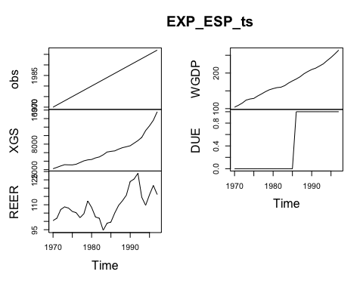

#  
XGS <- EXP_ESP_ts[,"XGS"]  
WGDP <- EXP_ESP_ts[,"WGDP"]  
REER <- EXP_ESP_ts[,"REER"]  
DUE <- EXP_ESP_ts[,"DUE"]  
#  
# Ecuación de exportaciones (1970-1997)  
lm_X_ESP <- lm(log(XGS) ~ log(WGDP) + log(REER))  
S(lm_X_ESP)

## Call: lm(formula = log(XGS) ~ log(WGDP) + log(REER))  
##   
## Coefficients:  
## Estimate Std. Error t value Pr(>|t|)   
## (Intercept) -0.24239 0.84432 -0.287 0.776   
## log(WGDP) 2.04618 0.06235 32.820 <2e-16 ***  
## log(REER) -0.34878 0.21480 -1.624 0.117   
## ---  
## Signif. codes: 0 '***' 0.001 '**' 0.01 '*' 0.05 '.' 0.1 ' ' 1  
##   
## Residual standard deviation: 0.06663 on 25 degrees of freedom  
## Multiple R-squared: 0.9853  
## F-statistic: 836.6 on 2 and 25 DF, p-value: < 2.2e-16   
## AIC BIC   
## -67.39 -62.06

#  
# Test de Chow de cambio estructural  
#  
SRCT <- sum(residuals(lm_X_ESP)^2)  
SRCT

## [1] 0.1109913

T <- nobs(lm_X_ESP)  
T

## [1] 28

K <- T -df.residual(lm_X_ESP)  
K

## [1] 3

# Pre UE  
nUE_dat <- window(EXP_ESP_ts, start=1970, end = 1985)  
lm_X_ESP_nUE <- lm(log(XGS) ~ log(WGDP) + log(REER) , data = nUE_dat)  
S(lm_X_ESP_nUE)

## Call: lm(formula = log(XGS) ~ log(WGDP) + log(REER), data = nUE_dat)  
##   
## Coefficients:  
## Estimate Std. Error t value Pr(>|t|)   
## (Intercept) 2.5078 1.6493 1.520 0.1523   
## log(WGDP) 1.8144 0.0846 21.447 1.57e-11 ***  
## log(REER) -0.6945 0.3187 -2.179 0.0483 *   
## ---  
## Signif. codes: 0 '***' 0.001 '**' 0.01 '*' 0.05 '.' 0.1 ' ' 1  
##   
## Residual standard deviation: 0.05124 on 13 degrees of freedom  
## Multiple R-squared: 0.9763  
## F-statistic: 267.8 on 2 and 13 DF, p-value: 2.725e-11   
## AIC BIC   
## -44.99 -41.90

SRC1 <- sum(residuals(lm_X_ESP_nUE)^2)  
SRC1

## [1] 0.03413817

T1 <- nobs(lm_X_ESP_nUE)  
T1

## [1] 16

# Post UE  
UE_dat <- window(EXP_ESP_ts, start=1986, end = 1997)  
lm_X_ESP_UE <- lm(log(XGS) ~ log(WGDP) + log(REER) , data = UE_dat)  
S(lm_X_ESP_UE)

## Call: lm(formula = log(XGS) ~ log(WGDP) + log(REER), data = UE_dat)  
##   
## Coefficients:  
## Estimate Std. Error t value Pr(>|t|)   
## (Intercept) -1.6788 0.8889 -1.889 0.09153 .   
## log(WGDP) 2.6425 0.1032 25.610 1.02e-09 ***  
## log(REER) -0.7220 0.1933 -3.735 0.00466 **   
## ---  
## Signif. codes: 0 '***' 0.001 '**' 0.01 '*' 0.05 '.' 0.1 ' ' 1  
##   
## Residual standard deviation: 0.03661 on 9 degrees of freedom  
## Multiple R-squared: 0.9871  
## F-statistic: 344.6 on 2 and 9 DF, p-value: 3.133e-09   
## AIC BIC   
## -40.77 -38.83

SRC2 <- sum(residuals(lm_X_ESP_UE)^2)  
SRC2

## [1] 0.01206575

T2 <- nobs(lm_X_ESP_UE)  
T2

## [1] 12

# Comparación de parámetros  
compareCoefs(lm_X_ESP_nUE,lm_X_ESP_UE)

## Calls:  
## 1: lm(formula = log(XGS) ~ log(WGDP) + log(REER), data = nUE_dat)  
## 2: lm(formula = log(XGS) ~ log(WGDP) + log(REER), data = UE_dat)  
##   
## Model 1 Model 2  
## (Intercept) 2.508 -1.679  
## SE 1.649 0.889  
##   
## log(WGDP) 1.8144 2.6425  
## SE 0.0846 0.1032  
##   
## log(REER) -0.694 -0.722  
## SE 0.319 0.193  
##

# Test de Chow  
CHOW=((SRCT-(SRC1+SRC2))/K)/((SRC1+SRC2)/(T-2*K))  
CHOW

## [1] 10.28284

pval <- 1-pf(CHOW,3,(28-2*3))  
pval

## [1] 0.0001978374

#  
sctest(log(XGS) ~ log(WGDP) + log(REER), data=EXP_ESP_ts, type = "Chow", point = T1)

##   
## Chow test  
##   
## data: log(XGS) ~ log(WGDP) + log(REER)  
## F = 10.283, p-value = 0.0001978

#  
# Test de Chow recursivo  
#   
fs <- Fstats(lm(log(XGS) ~ log(WGDP) + log(REER)), data=EXP_ESP_ts, from = 0.15, to = 0.85)  
## plot the F statistics  
plot(fs, alpha = 0.01)

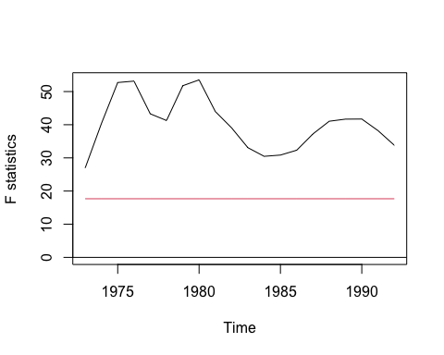

## and the corresponding p values  
plot(fs, pval = TRUE, alpha = 0.01)

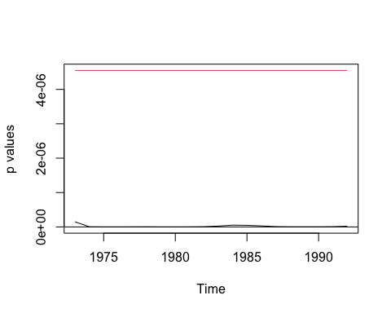

#  
# Ecuación de exportaciones por tramos  
#  
lm_X_ESP_2 <- lm(log(XGS) ~ (log(WGDP) + log(REER))*DUE)  
S(lm_X_ESP_2)

## Call: lm(formula = log(XGS) ~ (log(WGDP) + log(REER)) * DUE)  
##   
## Coefficients:  
## Estimate Std. Error t value Pr(>|t|)   
## (Intercept) 2.50775 1.47498 1.700 0.1032   
## log(WGDP) 1.81445 0.07566 23.982 < 2e-16 ***  
## log(REER) -0.69447 0.28504 -2.436 0.0234 *   
## DUE -4.18659 1.84754 -2.266 0.0336 *   
## log(WGDP):DUE 0.82803 0.14968 5.532 1.47e-05 ***  
## log(REER):DUE -0.02750 0.37389 -0.074 0.9420   
## ---  
## Signif. codes: 0 '***' 0.001 '**' 0.01 '*' 0.05 '.' 0.1 ' ' 1  
##   
## Residual standard deviation: 0.04583 on 22 degrees of freedom  
## Multiple R-squared: 0.9939  
## F-statistic: 713.6 on 5 and 22 DF, p-value: < 2.2e-16   
## AIC BIC   
## -85.93 -76.61

#  
UE <- factor(DUE, labels=c("nUE", "UE"))  
lm_X_ESP_3 <- lm(log(XGS) ~ (log(WGDP) + log(REER))*UE)  
S(lm_X_ESP_3)

## Call: lm(formula = log(XGS) ~ (log(WGDP) + log(REER)) * UE)  
##   
## Coefficients:  
## Estimate Std. Error t value Pr(>|t|)   
## (Intercept) 2.50775 1.47498 1.700 0.1032   
## log(WGDP) 1.81445 0.07566 23.982 < 2e-16 ***  
## log(REER) -0.69447 0.28504 -2.436 0.0234 *   
## UEUE -4.18659 1.84754 -2.266 0.0336 *   
## log(WGDP):UEUE 0.82803 0.14968 5.532 1.47e-05 ***  
## log(REER):UEUE -0.02750 0.37389 -0.074 0.9420   
## ---  
## Signif. codes: 0 '***' 0.001 '**' 0.01 '*' 0.05 '.' 0.1 ' ' 1  
##   
## Residual standard deviation: 0.04583 on 22 degrees of freedom  
## Multiple R-squared: 0.9939  
## F-statistic: 713.6 on 5 and 22 DF, p-value: < 2.2e-16   
## AIC BIC   
## -85.93 -76.61